

Project Name: ***Timekeeping Integration***

Ellipse Inbound Applications

Deployment Guide

Version: ***1.1***

Date: ***Jan 6, 2012***

Currently the documents are contained in Clarity: Warehouse Management 2011 project

Document Control

|  |  |  |  |
| --- | --- | --- | --- |
| Revision Number. | Date of Issue | Prepared By | Brief Description of Change |
| V1.0 | Jan 6, 2011 | Bill Zhang | First delivery of Ellipse inbound interface for middleware development team to test the connectivity. |
|  |  |  |  |
|  |  |  |  |
|  |  |  |  |
|  |  |  |  |
|  |  |  |  |
|  |  |  |  |

Distribution History

|  |  |  |
| --- | --- | --- |
| **Revision Number.** | **Date of Issue** | **Recipients** |
|  |  |  |
|  |  |  |
|  |  |  |
|  |  |  |
|  |  |  |

Table of contents

Table of contents 3

1. Introduction 4

2. Ellipse Configuration 5

2.1. New Ellipse Part Status Table Code 5

2.2. New Ellipse XX Table Codes 6

2.3. New Ellipse #EUM Table Codes 8

2.1. New Ellipse #EWH Table Codes 10

2.2. Ellipse Batch Configuration 11

2.2.1. THXCAT – Catalog Batch Extract 11

2.2.2. THXSUP – Supplier Batch Extract 15

3. Database Configuration 20

4. Component Installation 21

4.1. Extract Programs and Configuration Files Upload 21

4.2. Ellipse Admin Console – EAC 23

4.3. Local Batch XML 24

4.4. Test New Environment Variable 24

# Introduction

This guide has been created to assist with the installation and configuration of the Group 1 applications (Ellipse outbound interface programs).

# Ellipse Configuration

N/A

# Database Configuration

N/A

# Component Installation

## Websphere Admin Console

Add the following six entries in the application server’s JVM setting as below. The TimeKeepIntegration.config can be downloaded in the next step.

|  |  |
| --- | --- |
| [**Property**](http://localhost:9090/admin/propertyCollection.do?EditAction=true&refId=Property_1315773012676&contextId=cells:heco-eesNetwork:nodes:heco-ees:servers:TimeLink&resourceUri=server.xml&perspective=tab.configuration) **Name** | **Value** |
| [com.mincom.ellipseconnectionpool.config.connectiontimeout](http://localhost:9090/admin/propertyCollection.do?EditAction=true&refId=Property_1315773012676&contextId=cells:heco-eesNetwork:nodes:heco-ees:servers:TimeLink&resourceUri=server.xml&perspective=tab.configuration) | 3600 |
| [com.mincom.ellipseconnectionpool.config.scheduleinterval](http://localhost:9090/admin/propertyCollection.do?EditAction=true&refId=Property_1305737360707&contextId=cells:heco-eesNetwork:nodes:heco-ees:servers:TimeLink&resourceUri=server.xml&perspective=tab.configuration) | 1800 |
| [com.mincom.ellipseconnectionpool.config.scheduleinterval](http://localhost:9090/admin/propertyCollection.do?EditAction=true&refId=Property_1305737360707&contextId=cells:heco-eesNetwork:nodes:heco-ees:servers:TimeLink&resourceUri=server.xml&perspective=tab.configuration) | 60 |
| [com.thec.timelink.ejbcommon.config](http://localhost:9090/admin/propertyCollection.do?EditAction=true&refId=Property_1325625423021&contextId=cells:heco-eesNetwork:nodes:heco-ees:servers:TimeLink&resourceUri=server.xml&perspective=tab.configuration) | <path>\[TimeKeepIntegration.config](https://github.com/bz3361/THEC-TimeLink-Distribution/blob/master/TmeKeepIntegration.config) |
| [com.thec.wms.ejbcommon.config](http://localhost:9090/admin/propertyCollection.do?EditAction=true&refId=Property_1309627372797&contextId=cells:heco-eesNetwork:nodes:heco-ees:servers:TimeLink&resourceUri=server.xml&perspective=tab.configuration) | <path>\[TimeKeepIntegration.config](https://github.com/bz3361/THEC-TimeLink-Distribution/blob/master/TmeKeepIntegration.config) |

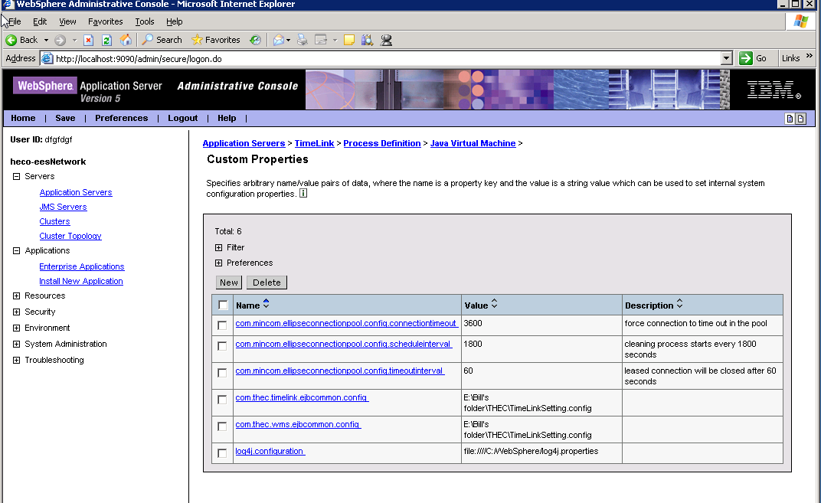

## Download Applications

* Here is the list of the applications to be downloaded and installed:

EllipseConnectionPool.ear

THECLabourCosting.ear

THECVehicleCosting.ear

TimeKeepIntegration.config

* Go to <https://github.com/bz3361/THEC-TimeLink-Distribution>. You will see:

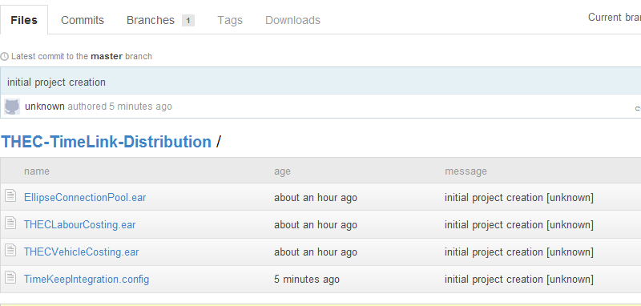

* Click on the application to be downloaded. You will see:

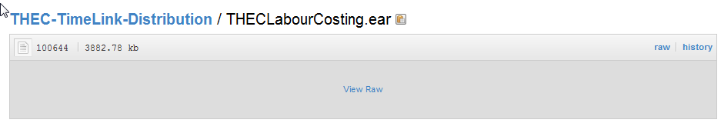

* Click on the ‘View Raw’ link to download the application.
* Continue the above process to get all the applications downloaded.
* Install all the ear files in WAS Admin Console.
* Update TimeKeepIntegration.config: endpoint element needs to changed to the app server’s RMI port.

The introduction should describe the *data interchange* in terms of Purpose, Scope, Plan evolution, References and Definitions and acronyms.